|  |
| --- |
|  |

|  |  |  |
| --- | --- | --- |
|  | Atos – For Internal Use |  |
| Copyright © 2015 Atos India Private Limited. | | |

|  |
| --- |
| Version 1.0 |

|  |
| --- |
| FD\FD01 |

|  |
| --- |
| Atos SOCLOMO Platform  Analytics As A Service |

All rights reserved. Reproduction in whole or in part is prohibited without the prior written consent of the copyright owner.

Document control

Issue control

|  |  |  |
| --- | --- | --- |
| Author | Role | Signature |
| Sandeep Gawde | Lead Consultant |  |
|  |  |  |

|  |  |  |
| --- | --- | --- |
| Owner and approver | Signature | Sign off Date |
|  |  |  |
|  |  |  |

|  |  |  |
| --- | --- | --- |
| Reviewers | Signature | Sign Off Date |
|  |  |  |
|  |  |  |
|  |  |  |

Version history

|  |  |  |
| --- | --- | --- |
| Version | Date | Comment |
| 0.1 | 17/11/2015 | Initial version |
| 0.2 | 17/11/2015 | Formatting changes |
| 0.3 | 18/11/2015 | Added Architecture section |
|  |  |  |
|  |  |  |
|  |  |  |
|  |  |  |
|  |  |  |
|  |  |  |

Contents

1. Introduction 4

1.1 Purpose 4

1.2 Scope of this document 4

1.3 Definitions, Acronyms and Abbreviations 4

2. Market Trend around Analytics as a Platform 5

3. QlikView / QlikSense Platform 7

3.1 QlikSense Overview 7

4. Qlik Architecture 8

5. QlikSense Desktop Deployment Steps 12

5.1 Filter Pane 13

5.2 Bar chart 14

5.3 Line Chart 15

5.4 Pie Chart 15

# Introduction

## Purpose

This document elaborates

* Market Trend around Analytics Platform
* QlikView / QlikSense as Analytics platform
* Development process for building dashboard
* Env set up for QlikView / QlikSense servers
* Support structure for QlikView / QlikSense

## Scope of this document

The documents provides an overview of Analytics as a Service trend. It then provides details considering QlikSense / QlikView solution as platform and discusses detailed steps of performing development as well as deployment of QlikSense sample solution. Finally, it provides overview of existing services and support structure in place.

References

The following documents are referenced by the DFD:

| No | Document | Version/Date |
| --- | --- | --- |
|  | QlikSense Installation Guide | 1.1 |
|  | Qliksense Tutorial |  |
|  |  |  |
|  |  |  |

## Definitions, Acronyms and Abbreviations

| No | Document | Description |
| --- | --- | --- |
|  |  |  |
|  |  |  |
|  |  |  |
|  |  |  |

# Market Trend around Analytics as a Platform

Business intelligence and analytics software has rapidly gained traction in the market and is considered to be the fastest growing industry in IT. Organizations are in dire need of tools that streamline their business process by quickly analyzing, optimizing, and managing the exponential increase in data. All these functionalities are encompassed within a single console which lets organizations analyze the right data at right time and helps to understand the behavior and changing preferences of customer and monitor the performance of each and every resource of the organization. Hence the usage of these tools is ubiquitously seen across all the industry vertical.

The proliferation of business intelligence and analytics software is significant in large enterprises; however, small and medium organizations are also looking for investing in this software as the benefit associated with it encourages its adoption. However the popularity of cloud deployment options has given enormous benefits to the SMB’s and significantly increased their adoption rate. In the years to come, this trend is anticipated to continue leveraging software providers to offer more innovative solution with intelligent and smart dashboards with distinctive feature to cater the emerging need of self-service analytics. Customer analytics, social media analytics, predictive analytics, and embedded BI are some other growth pointers in this market which is shifting vendor’s interest towards delivering these needs. On the other hand certain restraints such as data integration and most importantly lack of skilled and knowledgeable personnel’s for optimizing the effectiveness of tools hinder its market growth. Hence the demand for BI and analytics training will continue to increase. Along with this, analysis of need and finding right data for analysis, are some other challenges being faced by the vendors.

The BI and analytics segments include BI platforms, CPM suites, advanced and predictive analytics, content analytics, and analytics application. The services are segmented as professional services, and managed services. Further, the deployment type is categorized into on-premises and on- cloud.

The research report categorizes the Business Intelligence and Analytics Software market to forecast the revenues and analyze the trends in each of the following sub-markets:

On the basis of segment and services:

* Segment
  + Business Intelligence (BI) Platforms
  + Advanced and Predictive Analytics
  + Content Analytics
  + Analytics Application
* Services
  + Professional Services
  + Managed Services

On the basis of deployment modes:

* On-premise
* Cloud

Analytics-as-a-service is the latest operating model where analytics software and the infrastructure required to run analytics are delivered via cloud-based platforms. Analytics-as-a-service is becoming a valuable option for businesses that do not have capital budget and internal expertise to implement and manage in-house analytics infrastructures. It is also useful for companies that are face increasing amount of data coming from various sources and operate in established structures that make upgrading the existing infrastructure difficult. The services available in the analytics-as-a-service model include the managed business services, consulting services, and support and maintenance services. Such advanced analytical tools enable organizations to bring in competences that they lack or to replace functions or processes that incurred huge recurring costs. These services reduce the recurring in-house operation costs and thus allow the organizations to increase their efficiency and focus on their core operations by transforming their in-house data on the cloud.

# QlikView / QlikSense Platform

## QlikSense Overview

Qlik Sense is a platform for data analysis. With Qlik Sense you can analyze data and make data discoveries on your own. You can share knowledge and analyze data in groups and across organizations. Qlik Sense lets you ask and answer your own questions and follow your own paths to insight. Qlik Sense enables you and your colleagues to reach decisions collaboratively.

Most Business Intelligence (BI) products can help you answer questions that are understood in advance. But what about your follow-up questions? The ones that come after someone reads your report or sees your visualization? With the Qlik Sense associative experience, you can answer question after question after question, moving along your own path to insight. With Qlik Sense you can explore your data freely, with just clicks, learning at each step along the way and coming up with next steps based on earlier findings.

Qlik Sense generates views of information on the fly for you. Qlik Sense does not require predefined and static reports or you being dependent on other users – you just click and learn. Every time you click, Qlik Sense instantly responds, updating every visualization and view in the app with a newly calculated set of data and visualizations specific to your selections.

**The app model** - Instead of deploying and managing huge business applications, you can create your own Qlik Sense apps that you can reuse, modify and share with others. The app model helps you ask and answer the next question on your own, without having to go back to an expert for a new report or visualization.

**The associative experience** - Qlik Sense automatically manages all the relationships in the data and presents information to you using a green/white/gray metaphor. Selections are highlighted in green, associated data is represented in white, and excluded (unassociated) data appears in gray. This instant feedback enables you to think of new questions and continue to explore and discover.

**Collaboration and mobility** - Qlik Sense further enables you to collaborate with colleagues no matter when and where they are located. All Qlik Sense capabilities, including the associative experience and collaboration, are available on mobile devices. With Qlik Sense, you can ask and answer your questions and follow-up questions, with your colleagues, wherever you are.

# Qlik Architecture

**The QlikView Difference: The Associative Experience** - One of the QlikView’s primary differentiators is the associative user experience it delivers. QlikView is the leading Business Discovery platform. It enables users to explore data, make discoveries, and uncover insights that enable them to solve business problems in new ways. Business users conduct searches and interact with dynamic dashboards and analytics from any device. Users can gain unexpected business insights because QlikView:

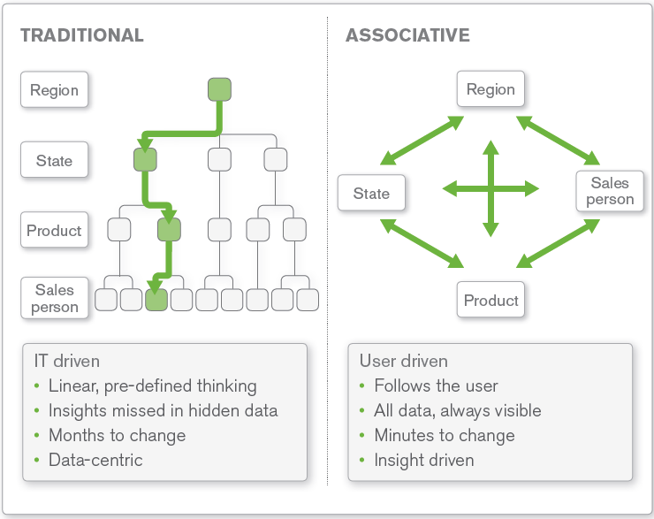

• Works the way the mind works. With QlikView, users can navigate and interact with data any way they want to — they are not limited to just following predefined drill paths or using preconfigured dashboards. Users ask and answer questions on their own and in groups and teams, forging new paths to insight and decision. With QlikView, discovery is flexible. Business users can see hidden trends and make discoveries like with no other BI platform on the market.

• Delivers direct — and indirect — search. With Google-like search, users type relevant words or phrases, in any order, and get instant, associative results. With a global search bar, users can search across the entire data set in an application. With search boxes affiliated with individual list boxes, users can confine the search to just that list box. They can both conduct direct and indirect searches. For example, if a user wanted to identify a sales rep but can’t remember the sales rep’s name — just details about the rep, such as that he sells fish to customers in the Nordic region — the user can search on the sales rep list box for “Nordic” and “fish” to get the names of sales reps who meet those criteria.

• Delivers answers as fast as users can think up questions. A user can ask a question in QlikView in many different ways, such as lassoing data in charts and graphs and maps, clicking on items in list boxes, manipulating sliders, and selecting dates in calendars. Instantly, all the data in the entire application filters itself instantly around the user’s selections. The user can quickly and easily see relationships and find meaning in the data, for a quick path to insight. The user can continue to click on field values in the application, further filtering the data based on questions that come to mind.

• Illuminates the power of gray. With QlikView, users can literally see relationships in the data. They can see not just which data is associated with the user’s selections — they can just as easily see which data is not associated (see Figure 1). How? The user’s selections are highlighted in green. Field values related to the user’s selection are highlighted in white. Unrelated data is highlighted in gray. For example, when a user clicks on a product category (say, bagels) and a region (e.g., Japan), QlikView instantly shows everything in the entire data set that is associated with these selections — as well as the data that is not associated. The result? New insights and unexpected discoveries.

**Components of the QlikView Business Discovery Platform**

The QlikView Business Discovery platform consists of 3 major components – QlikView Server, QlikView Publisher and QlikView Desktop, each playing an important part in designing, developing and implementing almost every QlikView deployment

Each component is used primarily by either an IT professional, a business analyst/developer, or a business user.

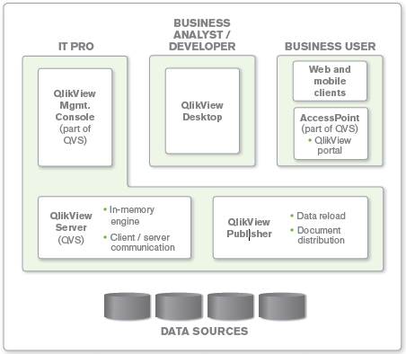

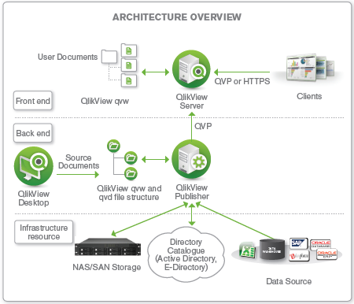

QLIKVIEW DESKTOP - The QlikView Desktop is a Windows-based desktop tool that is used by business analysts and developers to create a data model and to lay out the graphical user interface (GUI or presentation layer) for QlikView apps. It is within this environment where a developer will use a SQL-like scripting environment (augmented by ‘wizards’) to create the linkages (connection strings) to the source data and to transform the data (e.g. rename fields, apply expressions) so that it can be analyzed and used within the UI, as well as re-used by other QlikView files. The QlikView Desktop is also the environment where all user interface design and user experience is developed in a drag-and-drop paradigm: everything from graphs and tables containing slices of data to multi-tab architectures to application of color scheme templates and company logos is done here. The file type that is created using the QlikView Desktop is known as a QVW (.qvw, or QlikView file). Upon reload, a QVW can be used to create a data-only QVD (QlikView data) file, which is binary and contains no UI.

QLIKVIEW SERVER (QVS) - The QVS is a server-side product that contains the in-memory analytics engine and which handles all client/server communication between a QlikView client (i.e. desktop, IE plugin, AJAX or Mobile) and the server. It includes a management environment (QlikView Management Console) for providing administrator access to control all aspects of the server deployments (including security, clustering, distribution etc.) and also includes a web server to provide front-end access to the documents within. The web server’s user portal is known as Access Point. (It’s important to note that while the QVS contains its own web server, one can also utilize Microsoft IIS (Internet Information Server) for this purpose, too). The QVS handles client authorization against existing directory providers (e.g. Microsoft Active Directory, eDirectory) and also performs read and write to ACLs (access control lists) for QVW documents.

QLIKVIEW PUBLISHER

The QlikView Publisher is a server-side product that performs two main functions:

* It is used to load data directly from data sources defined via connection strings in the source QVW files.
* It is also used as a distribution service to reduce data and applications from source QVW files based on various rules (such as user authorization or data access privileges) and to distribute these newly-created documents to the appropriate QlikView Servers or as static PDF reports via email.

Data sources that can be readily accessed by QlikView include standard ODBC or OLEDBcompliant databases, standard flat files such as Microsoft Excel, XML, etc. as well as from systems such as SAP NetWeaver, Salesforce.com, and Informatica.

# QlikSense Desktop Deployment Steps

Below are screenshots for key steps for deployment of QlikSense desktop.

|  |  |  |
| --- | --- | --- |
| C:\Users\A597907\Desktop\Qliksense Learning Doc\1.PNG | C:\Users\A597907\Desktop\Qliksense Learning Doc\5.PNG | C:\Users\A597907\Desktop\Qliksense Learning Doc\6.PNG |
| C:\Users\A597907\Desktop\Qliksense Learning Doc\8.PNG | C:\Users\A597907\Desktop\Qliksense Learning Doc\Add data2.PNG | C:\Users\A597907\Desktop\Qliksense Learning Doc\Add data4.PNG |

**A sample Qliksense dashboard development example:**

Now we will be creating a dashboard consists of

* Filter pane (Filter)
* Barchart
* Line chart
* Pie chart

## Filter Pane

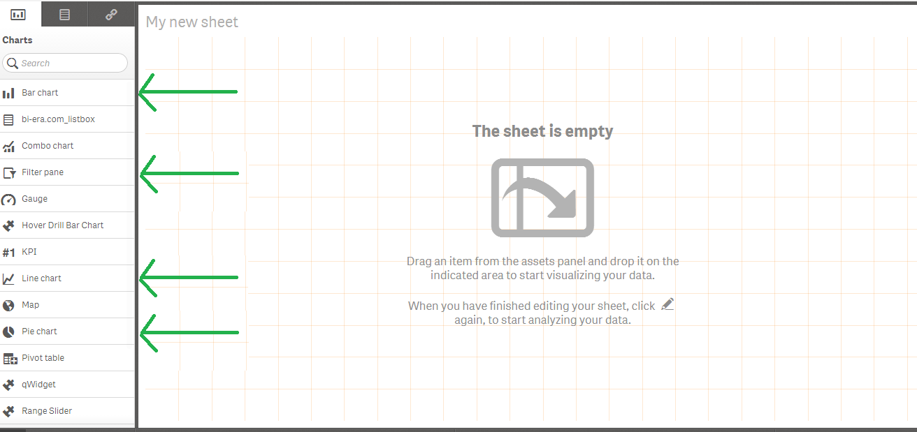

For filter we will be using Columns:

* Open Date
* Month
* Channel Type

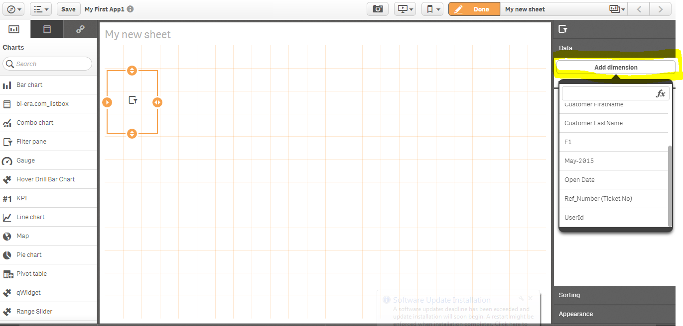

After dragging Filter Pane to sheet area, we can add dimension from right side as shown in above image.

## Bar chart

Once we drag Bar Chart option from left side then it will require:

* Dimension – X axis
* Expression – Y axis : Will be calculation. Ex- Count(column name),

sum(column name), avg(..), max(..), min(..) etc.

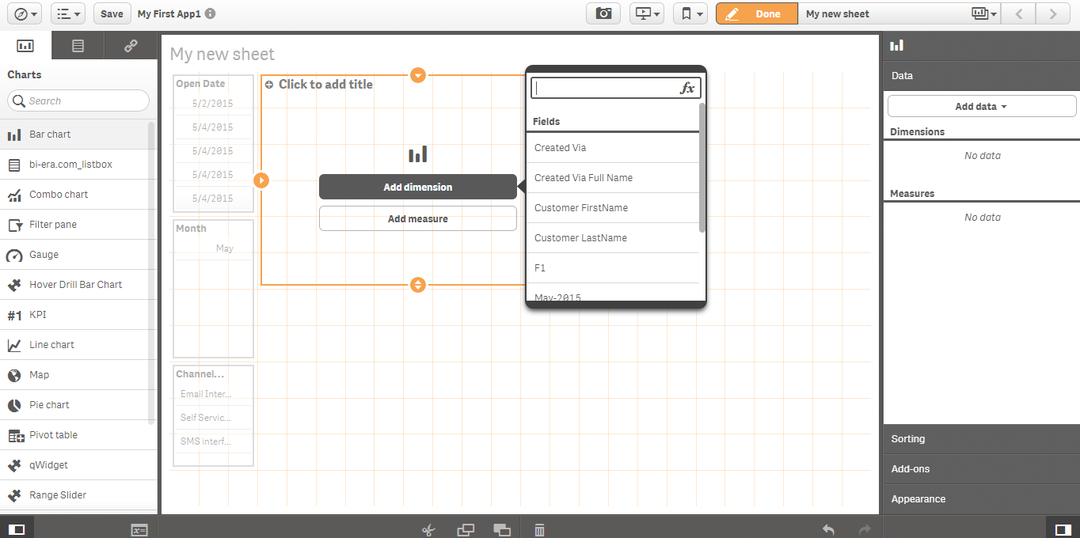

Here we will be taking

Dimension : “Created Via Full Name” Aliasing as Channel Type

Expression : Count([Ref_Number (Ticket No)]) as Ticket Count

* + Renaming Bar chart Title name as “Channel Wise Ticket count”.

It will look like below image

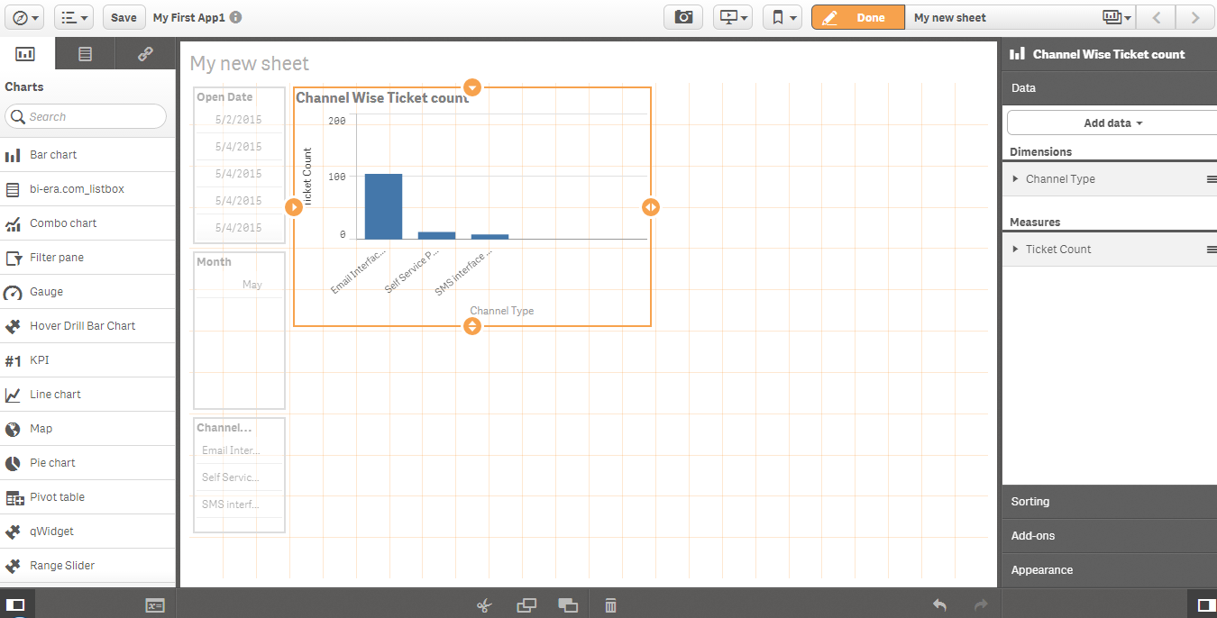

## Line Chart

Following the same steps as for Bar chart could be drawn Line chart

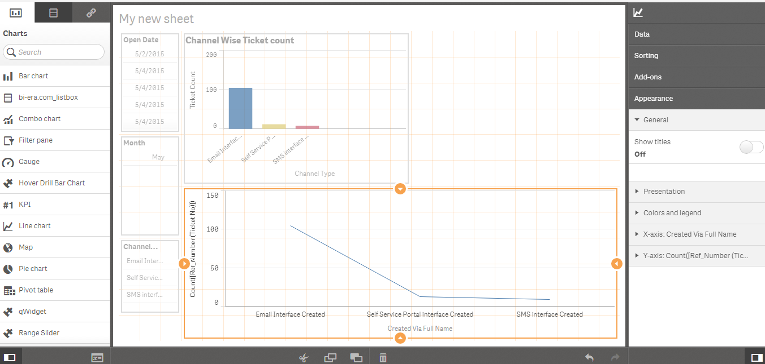

## Pie Chart

* Now considering dimension and expression same as for previous chart. Dashboard will look like below snapshot.

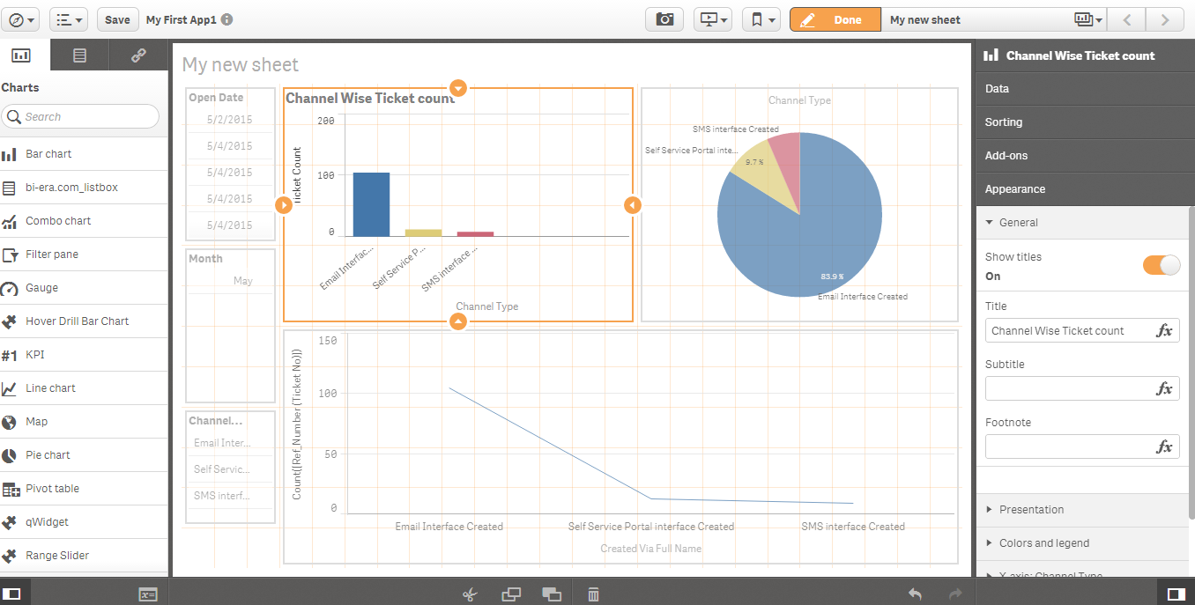

* Once editing is done then click on the “Done” button on the top.
* Final dashboard will look like below image.

